Intro to Business Name: __________________________
Franchise Assignment

Directions: A franchise is a written contract that gives a business the right to sell products and services in a specific way within a given area. A wide variety of familiar businesses within our community operate as franchises, including fast-food restaurants, pizza shops, motels, commercial cleaning companies, and weight loss centers.

Go to Franchise Direct.com. Complete the Drop-down menu together as follows:
- For the Industry menu, review the many industries in this menu.
- Select Restaurant Franchises
- Enter the Investment amount to “Any Amount”
- Select Find
Select Food Franchises
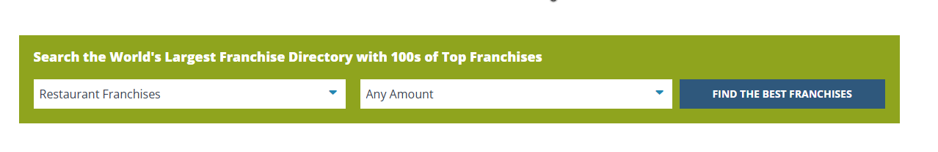
Any Amount
United States

Select Find

Select One listed by Teacher from first Row:
- Provide a brief description of what the franchise is.

- What does this company sell?

- What States are currently available for this franchise?

- What is the Franchise Fee amount?

- What is the Royalty Fees? If it is not listed in the Site, go to google and google it. We must google this for Shelly’s tea room. What is the royalty fee?

- How much Cash is required to start it?

- What is the total Investment Range

Now you Select two businesses of your choice. Any industry you want. Maybe check the industry you were looking at starting your business in the previous chapter.

Business #1 Business #2
Business Name and Industry
- Provide a brief description of what the franchise is.

What does this company sell?

What States are currently available for this franchise?

What is the Franchise Fee?

What is the Royalty Fees?

How much Cash is required to start it?

What is the total Investment Range

What type of operating assistance (ex: training, signage, advertising, does the franchiser provide?

Determine which of the two franchises you would rather open up. Explain your choice

What do you personally think would be the benefits of investing in a franchise instead of starting a similar business on your own?

